**Manufacture log for a micromouse.**

* **2 N20 high torque dc motors**
* **L298N motor driver**
* **sensors: front and side either infrared or ultrasonic sensors (3 infrared sensors).**
* **9V battery pack**
* **5v regulator**
* **2x drive wheels 32-40mm in diameter.**
* **Microcontroller (arduino uno)**

**Manufacturing costs:**

* **Cost for motors**
* **Cost for sensors**
* **Cost for 9v battery pack**
* **Motor driver cost**

**Total cost range is 15- 20 pounds depending on price of all these components**

**Clarification: total cost= 11.47 pounds.**

**Steps:**

* **cost of motors and drivers**
* **create a flow chart and get used to the tinkercad for electronics to be aware of dc motor short circuits.**
* **Design a program where the micromouse will do its functions.**
* **set up wiring for the individual components (needs analysis)**
* **layout of the entire simulation and how to compactly minimise room for it to be considered a micromouse**
* **3D cad design of the wheels.**

**Cad design of wheels and assembly of my prototypes base .**

**Initial sketch:**

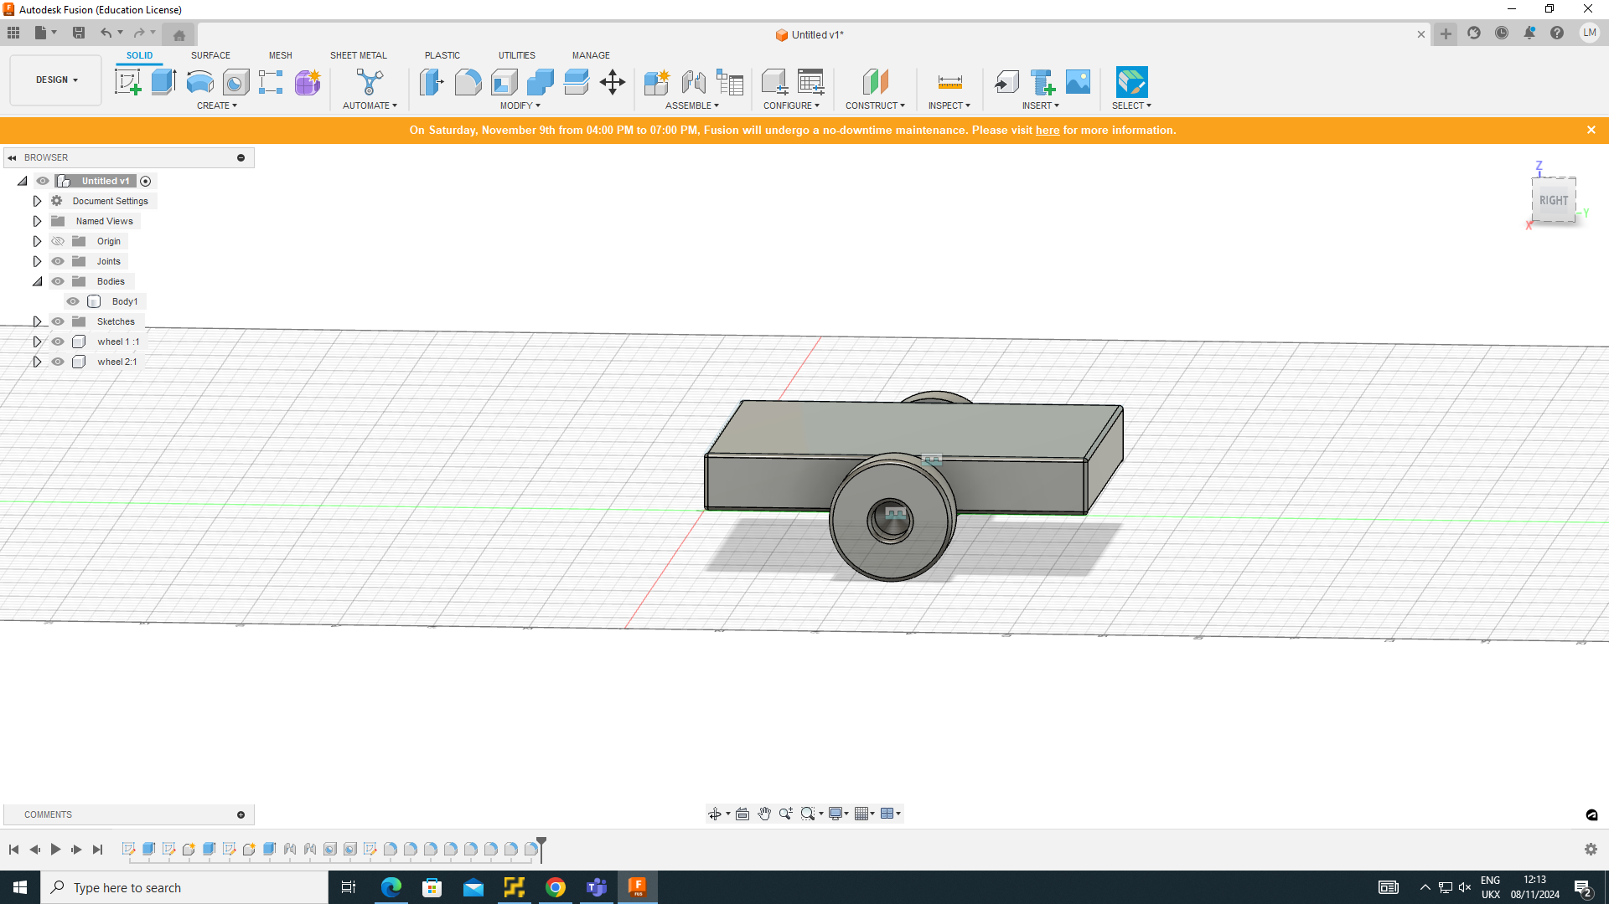

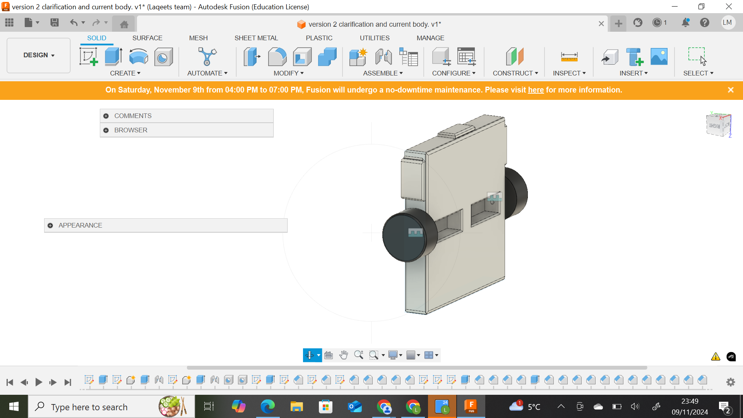

**Technical information**

**Important notes:**

Size and dimensions for the wheels are 32 mm in diameter and height of 15mm. The chamfering was 1mm thick on all sides and on the base which is 100x100mm in length. Initially I had some difficulty with the motor shaft but I realised that it can be attached by simply noting the size of a typical n20 motor and the rotors width. I then innovated this idea of extruding at a height of 10 inside the base since logically you can't have it spin when it's in exile of the wheels that wouldnt provide any torque. I saw many methods but this stuck out to me the most in its simplicity and compactness.

My concerns which i need to clarify

* The 3d printing of the design in itself is still premature and needs to be under review of somebody who is more insightful in fusion
* I'm still unsure if assembly would enable motion or it would just solidify the wheels in position.
* The size and dimensions on my finalised purchase of a batch of infrared sensors in relation to the sides and the front of the micromouse as they are just there as a rough outline of where the sensors should go and be attached.
* I'm still wondering what concerns I have with the design, perhaps the inclusion of the motor driver and other external components.
* I need to clarify a program or simulation of this. I also need an algorithm for this.

Reference point for what battery holder I need; future components will be enlisted later.

Evaluation and summary

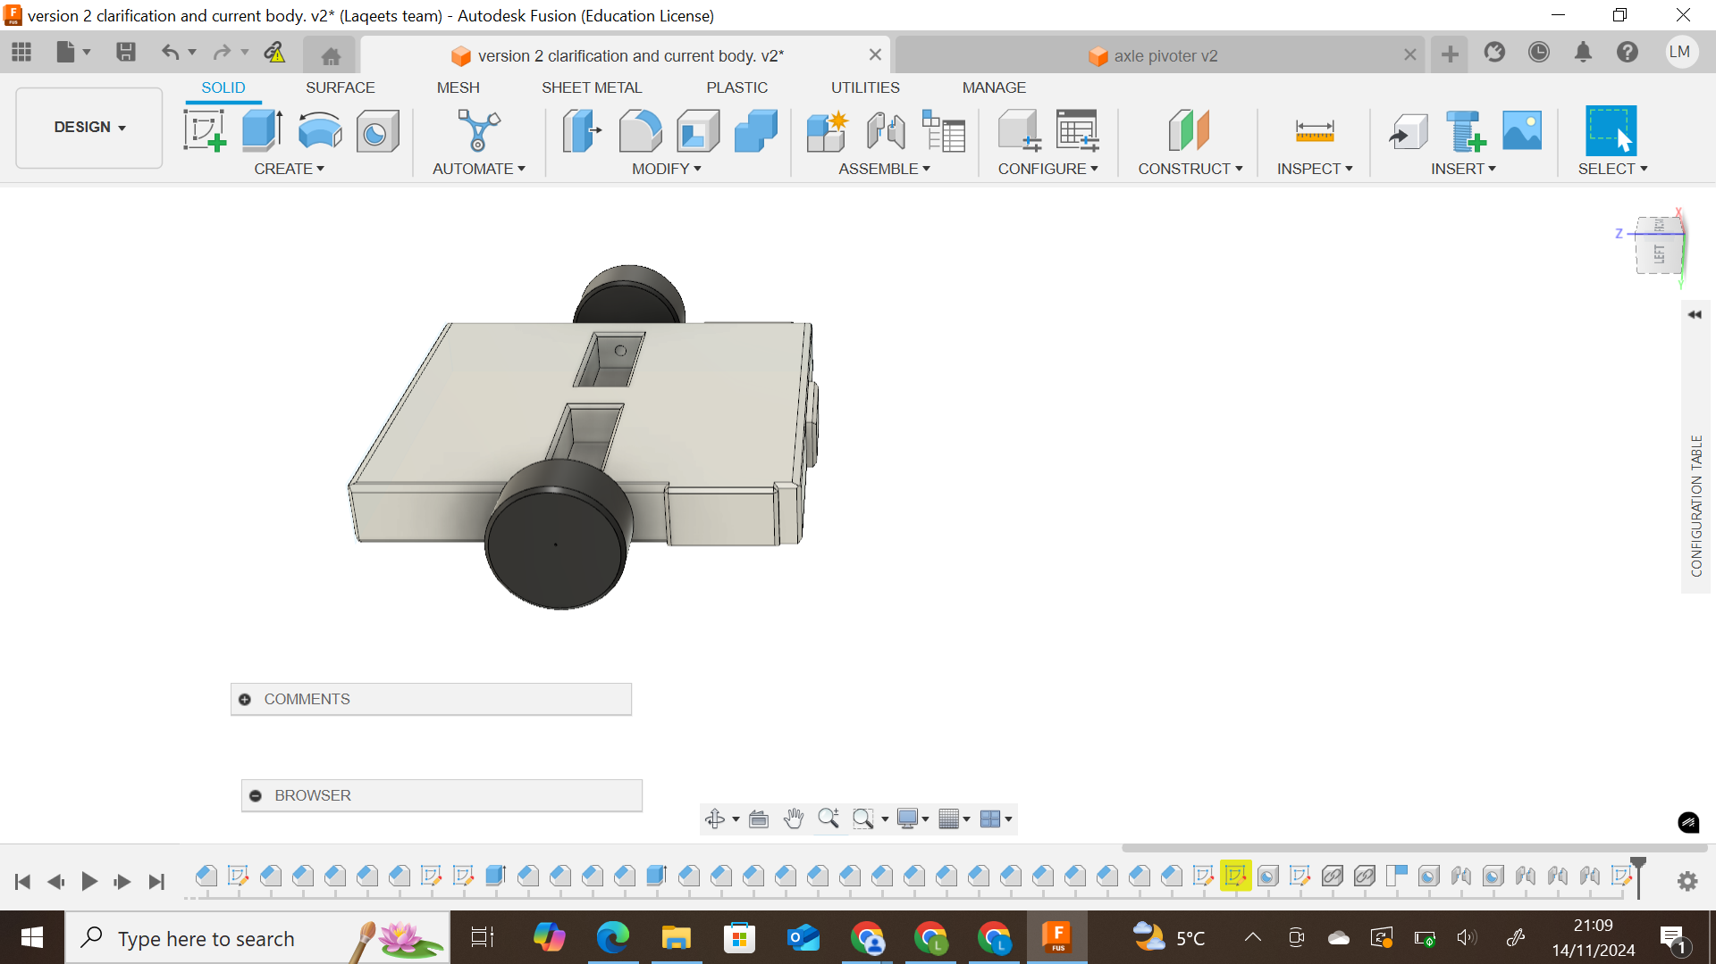

**Summary of what i've been doing.**

Here I have made a key adjuster which is adding an axle or pivoter to create less work for the motor along with manually pushing it to make sure it rolls. The close up below will clarify my adjustment that I have made which was simply adding copper axles (for aeshetical purposes) that drive the wheels quite simply. but are both separately distinguished as the motors will drive wheels at a higher speed and torque to change the directions when a wall has been detected hence why i separated them and installed it within the proximity of the motor mounting holes. I may make some adjustments in the placement of the motor which is the rectangular base extruded down at -10mm to make sure the rotor does fit since I'm quite sceptical if it would fit, but nonetheless i think it is ready for partial 3d printing to test if the parameters put in place would require change particularly if the components in assembly come out solidified which would be a major disastrous issue which i would need to concur with people of expertise to prevent and resolve.

***Next step: sample of the wheels to ensure rotation manually***

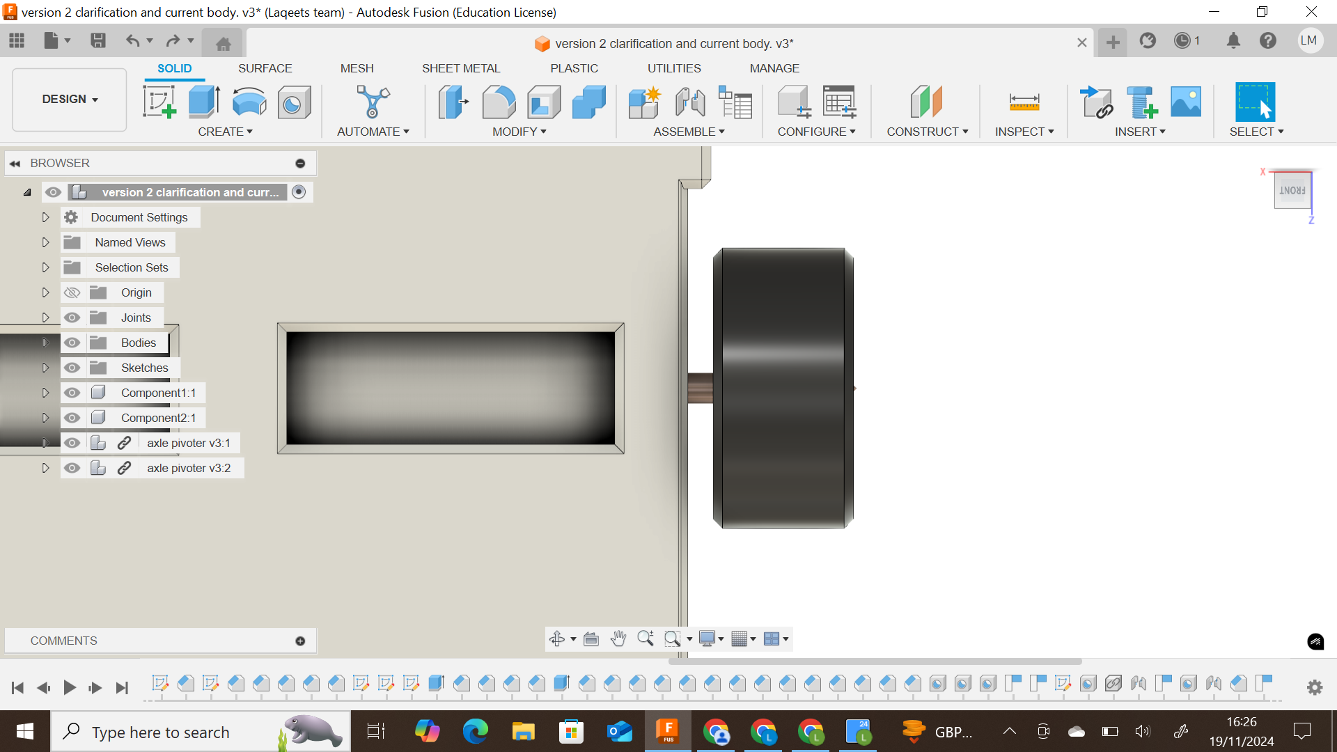

***Axle added with slight adjustments: ie tolerances of the printer were took account.***

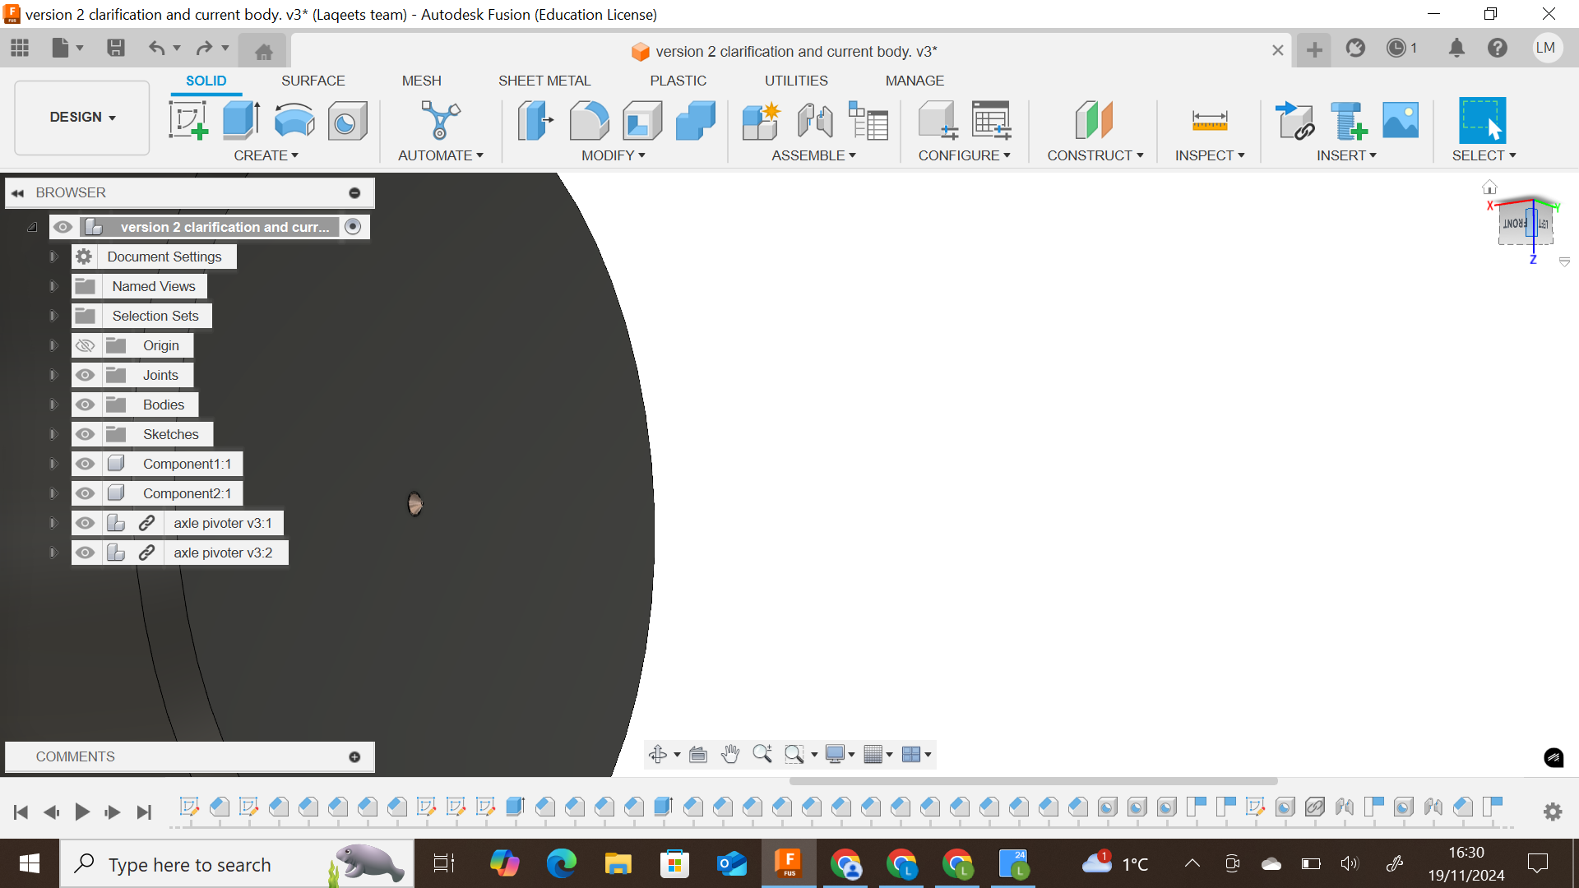

***Wheel axle tolerance end was adjusted.***

***Product design specification***

* ***TB6612FNG***
* ***2 high torque n20 motors***
* ***9v power supply.***
* ***Female jumper wires.***
* ***3 infrared sensors***
* ***Adhesive for the axle attachment (optional).***

***Psuedocode (wall finding algorithm for arduino uno)***

***#include <AFMotor.h>***

***// Motor pins***

***AF_DCMotor motor1(1);***

***AF_DCMotor motor2(2);***

***// IR sensor pins (example for front, left, right)***

***int frontSensor = A0;***

***int leftSensor = A1;***

***int rightSensor = A2;***

***void setup() {***

***motor1.setSpeed(255); // Full speed***

***motor2.setSpeed(255); // Full speed***

***pinMode(frontSensor, INPUT);***

***pinMode(leftSensor, INPUT);***

***pinMode(rightSensor, INPUT);***

***}***

***void loop() {***

***int frontValue = analogRead(frontSensor);***

***int leftValue = analogRead(leftSensor);***

***int rightValue = analogRead(rightSensor);***

***if (frontValue > 500) { // No wall in front***

***if (leftValue < 500) { // Wall on left***

***moveForward();***

***} else if (rightValue < 500) { // Wall on right***

***turnLeft();***

***} else {***

***turnRight();***

***}***

***} else { // Wall in front***

***if (leftValue < 500) { // Wall on left***

***moveForward();***

***} else {***

***turnLeft();***

***}***

***}***

***}***

***void moveForward() {***

***motor1.run(FORWARD);***

***motor2.run(FORWARD);***

***}***

***void turnLeft() {***

***motor1.run(BACKWARD);***

***motor2.run(FORWARD);***

***delay(500); // Adjust delay for proper turn***

***}***

***void turnRight() {***

***motor1.run(FORWARD);***

***motor2.run(BACKWARD);***

***delay(500); // Adjust delay for proper turn***

***Issues resolved***

* ***I have resolved the issue of soldering the wires onto the motor, the n20 motor is practically eligible for prototyping my micromouse.***
* ***Insulation of wires***

***Issues made***

* ***I need to get more jumper wires***
* ***I need a dc power supply to power my motor since it operates between 6-12 volts. The arduino only plays a role in controlling motor output in correspondence with the infrared sensors i've realised its volatility in some aspects of voltage supplementation especially considering the minimum voltage requirements for the n20 motors which are 300 rounds per minute***
* ***My initial n20 motor i soldered was not properly soldered, this was due to me using a soldering tip that wasn't right for the job,***

**personal engineered representation of the design:**

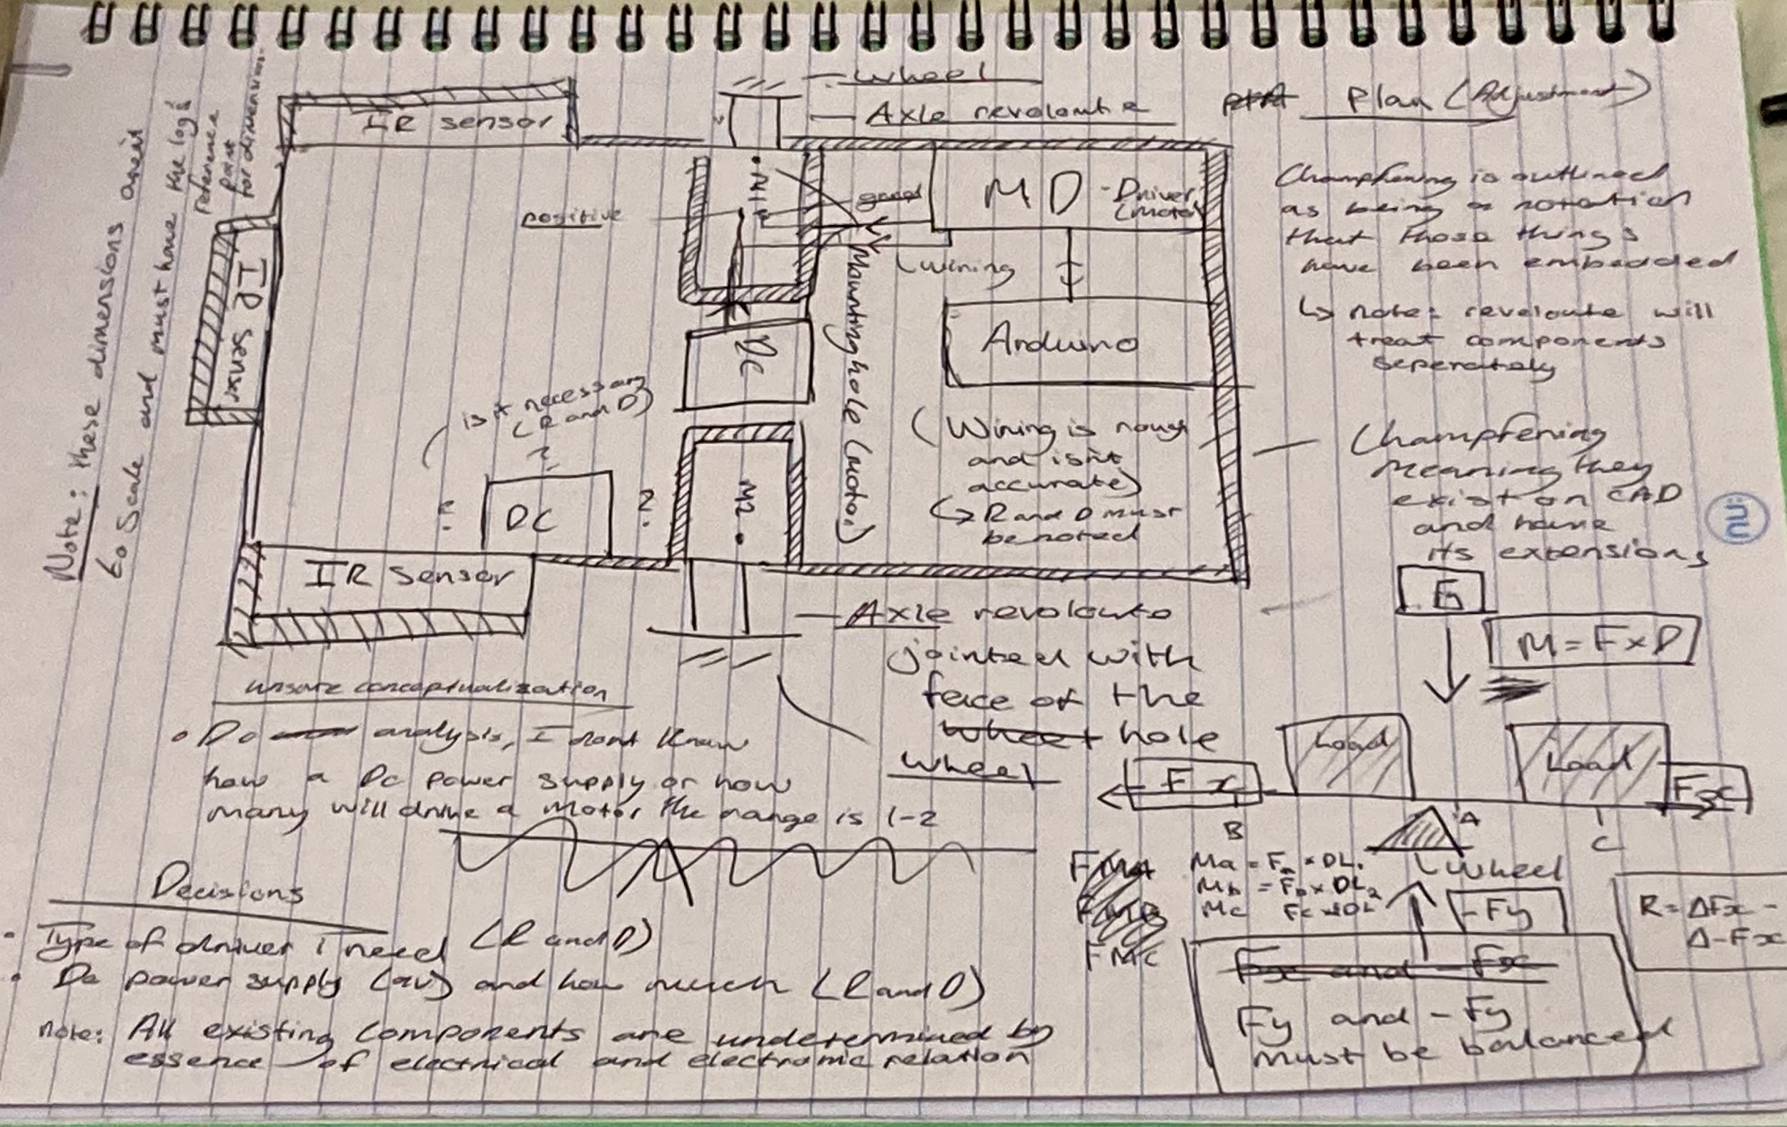

***As you can see, I have made some key adjustments to my overall design. I’ve also became more better at using engineering principles such as statics even though it may seem a bit vague. To clarify the statics, all I’m saying is the net force of the micromouse body and support forces which are the wheels have to be balanced on the forces of the functions of x that are positive and negative. This is because in a stable position ie applying Newton’s first law of motion which is to say an object stays in it’s consistent relative state until an unbalanced force is applied to the object in which case the following laws inhibit the chain reaction as a result of this applied force which can be a push or a pull but in this instance it would be pushing for manual rotation just for a sense of purpose behind what is in essence a robot car just scaled down as an oversimplification. So an object in stationary motion has to have itself balanced especially when an applied force in the fy direction is applied ie when I touch it from a vertical position (-Fy) will it tip over off of both sides on the fx direction when I apply a relatively small amount of force that dosent inhibit a persons whole weight but a relatively low percentage of it.***

***Summary and contextualisation***

***So as a summary and evaluation; will it tip over when I apply a reasonable amount of force at the ends? That completely depends on the stability of the micromouse wheels which I have positioned in the middle out of intuition and potential similarities in design when I did some research on others manufacturing a micromouse. The reason why they are in the centre is because there’s more active support on the entire body when it’s closer to the centre which is something called a centripetal force or a centralised support force if I was to be more specific as the wheels are supports in a right framework of terminology.***

***Soldering of the motor driver pin headers***

***It should be noted that the image below has me placing this on a breadboard please ignore the buzzer and other electronic components. Now on a quite blunt level I will say from an objective standpoint I did a very bad job at soldering. The reason? Well human beings have a tendency to do errors especially when it comes to the very first time in doing things that are new and unfamiliar. But to put it in a brief critical analysis I did not seek help from online videos in soldering simply because I watched a few which were vague in what tip to use and what temperature to use etc. And that was a major downside for me, since I did not know how to do this and what was needed to do this. To note I have done a better job of soldering as a result of this failure with a motor and soldering the wires onto the mount. But a positive which we can all be assured by is a good connection to the breadboard as shown in the photo .***

***Things to be aware of:***

***The major risk I may have is potential damage to the hardware in itself which I haven’t tested since this operates on a higher voltage typically between 9 to 12V complementary to the motors voltage specification and tolerance. But it should be noted that I did not apply the soldering iron on the physical part of the pcb I may have applied solder to the edges of the board but I didn’t directly apply the iron to the pcb which is something that’s worth mentioning for more clarification on what we are dealing with. Another side note is that the reason why I haven’t tested it in terms of functionality is because the only real power supply I have is an Arduino Uno board which typically has a voltage supply of 3.3-5V below the specification of what the TB6612FNG’s minimal operating voltage is which is a mentioned is between 9-12 volts. 12 being the maximum possible voltage.*** 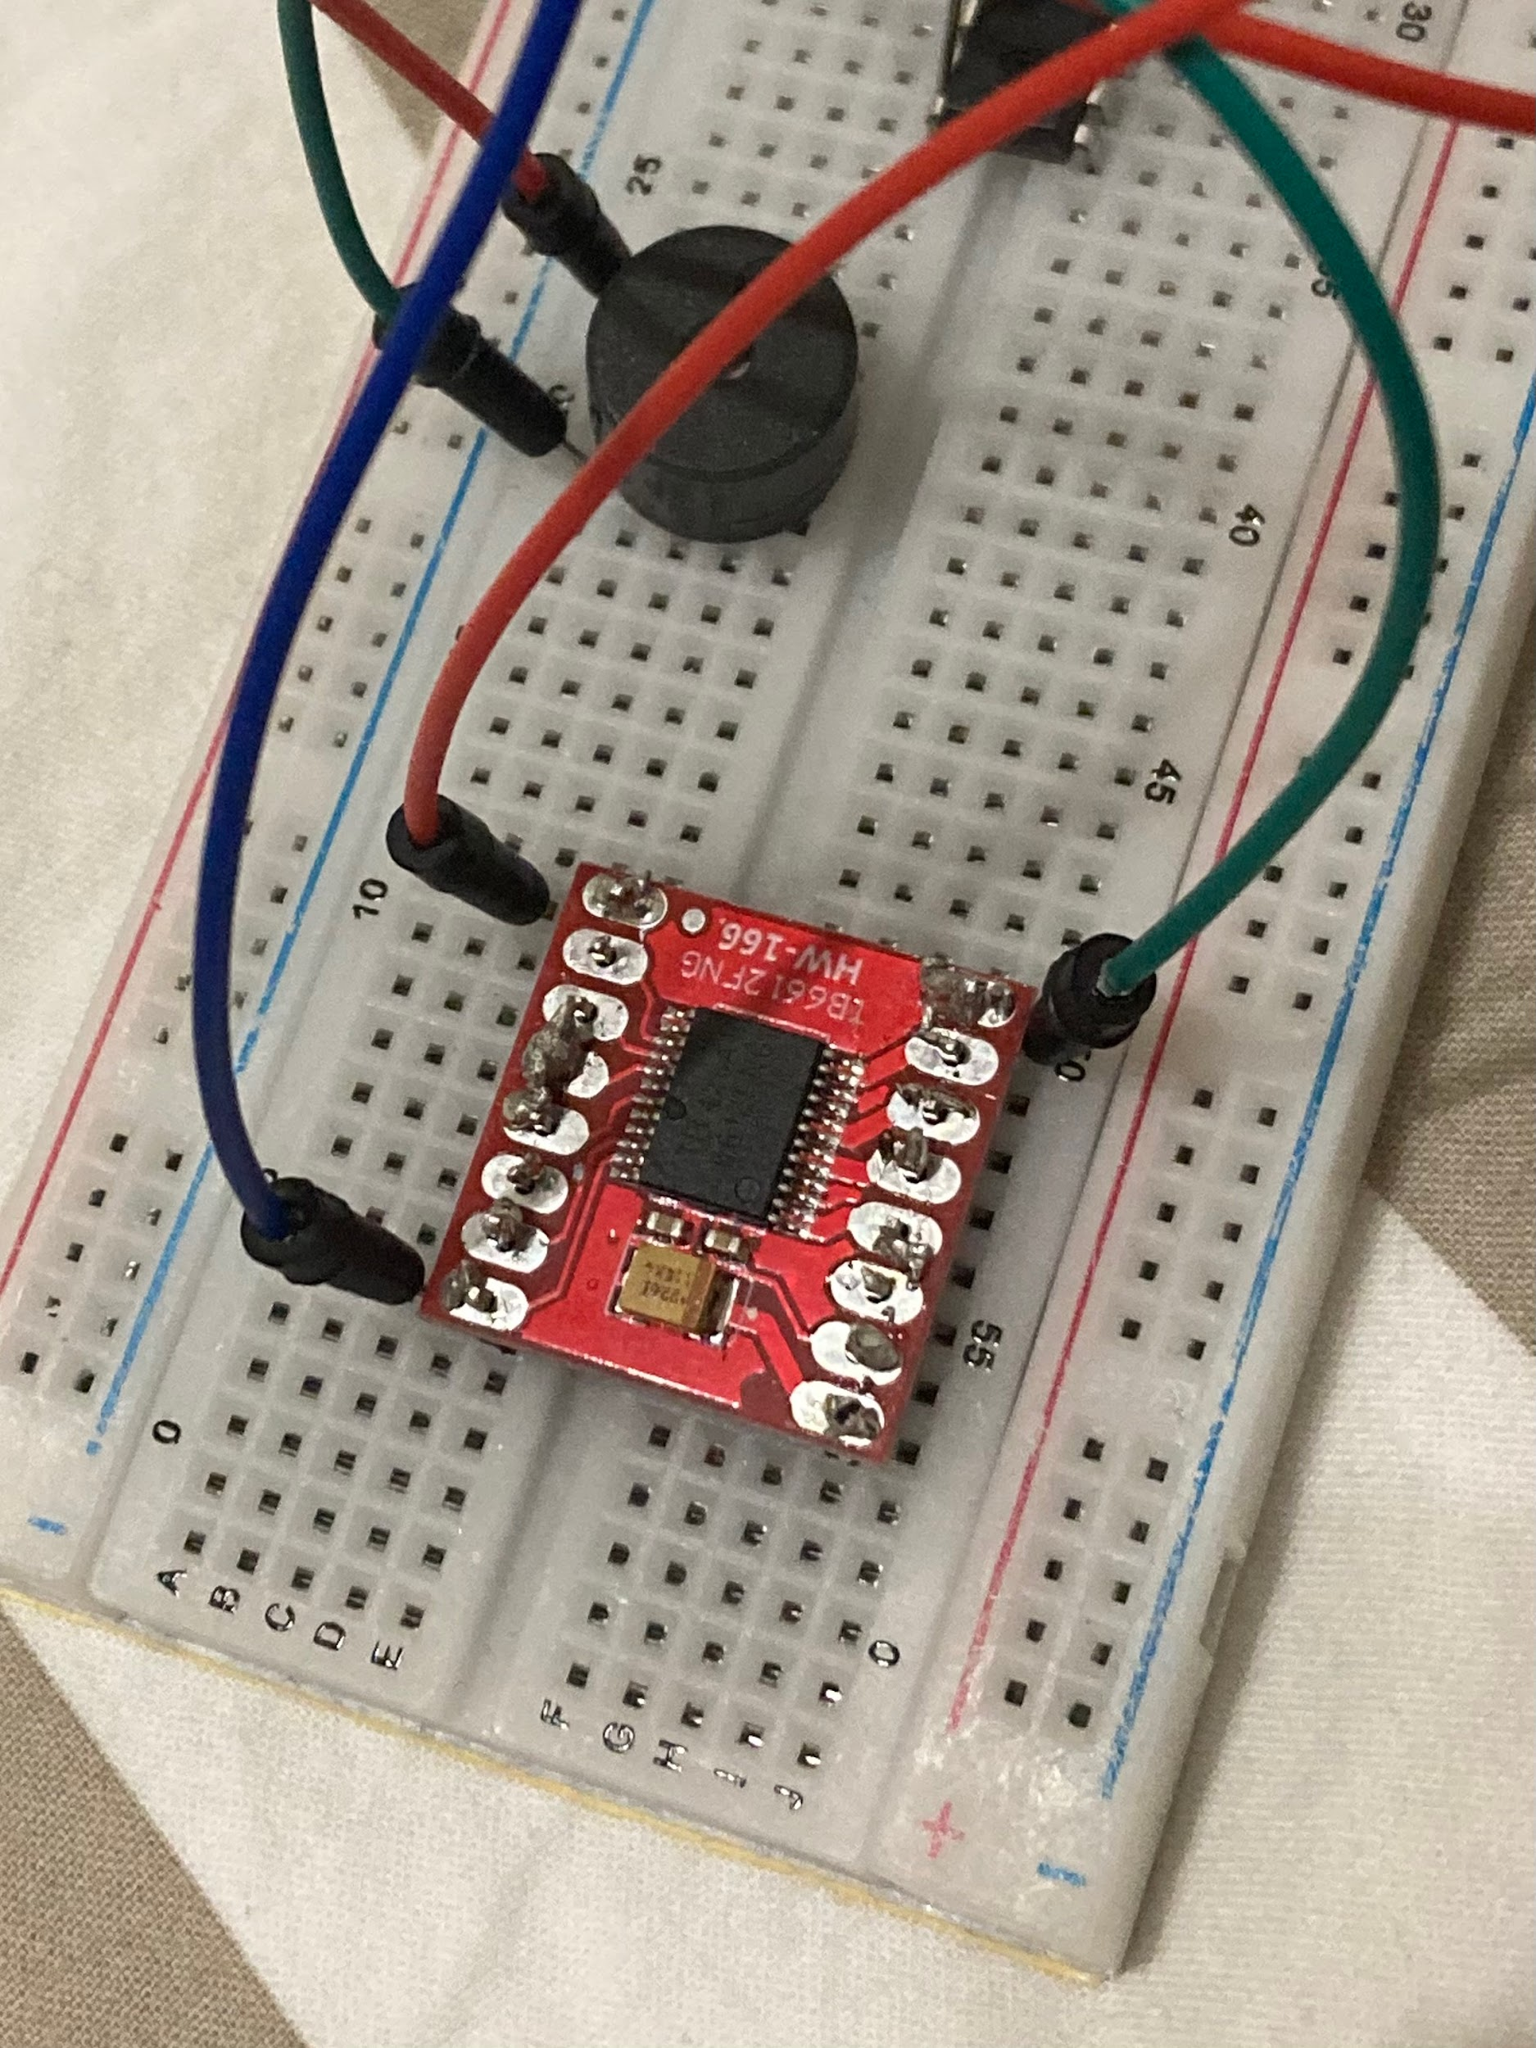

***What’s happening now in terms of progress?***

***Well, as of now the progress I have made is minimal. it’s usually been adding tweaks to the design layout in order for a thorough examination of what I’m doing. Recently I have ran into a very crucial issue and that is that my laptop which I have used has some technical issues in terms of hardware function or power modulation and I would need to have it examined by somebody more knowledgeable in technical aspects of hardware as I’m not practically competent at it to put it bluntly and simply.***